WEEK 2 INTERNSHIP TASK
Advanced Data Visualization and Storytelling with Python

Dataset | IBM HR Analytics Employee Attrition & Performance
Domain | Human Resources / Employee Attrition
Analysis | Advanced Visualization and Data Storytelling
Tools | Python, Pandas, Matplotlib, Seaborn, Google Colab
Dataset Size | 1470 rows × 32 columns

Internship Week 2 Report

1. Introduction
The objective of Week 2 was to extend the exploratory analysis performed during Week 1 by developing advanced visualizations and presenting the findings as a coherent data story. The same cleaned IBM HR Analytics Employee Attrition and Performance dataset was used so that the analysis could build directly on the data preparation work completed earlier.
The analysis focuses on employee attrition and explores how employee age, job role, income, job level, satisfaction, work-life balance and overtime relate to employee turnover. The visualizations were selected to communicate patterns to a non-technical audience while retaining analytical value.

2. Methods
The cleaned dataset generated during Week 1 was loaded using Pandas. Derived variables such as age groups and attrition rates were calculated to make comparisons meaningful. Seaborn and Matplotlib were then used to create five advanced visualizations.
The analysis uses percentages and distributions wherever appropriate rather than relying only on raw employee counts. This prevents differences in group size from misleading the interpretation. Heatmaps were used to compare multiple dimensions efficiently, while violin plots were used to show the shape and spread of income distributions.

3. Visualization 1: Attrition Rate by Age Group
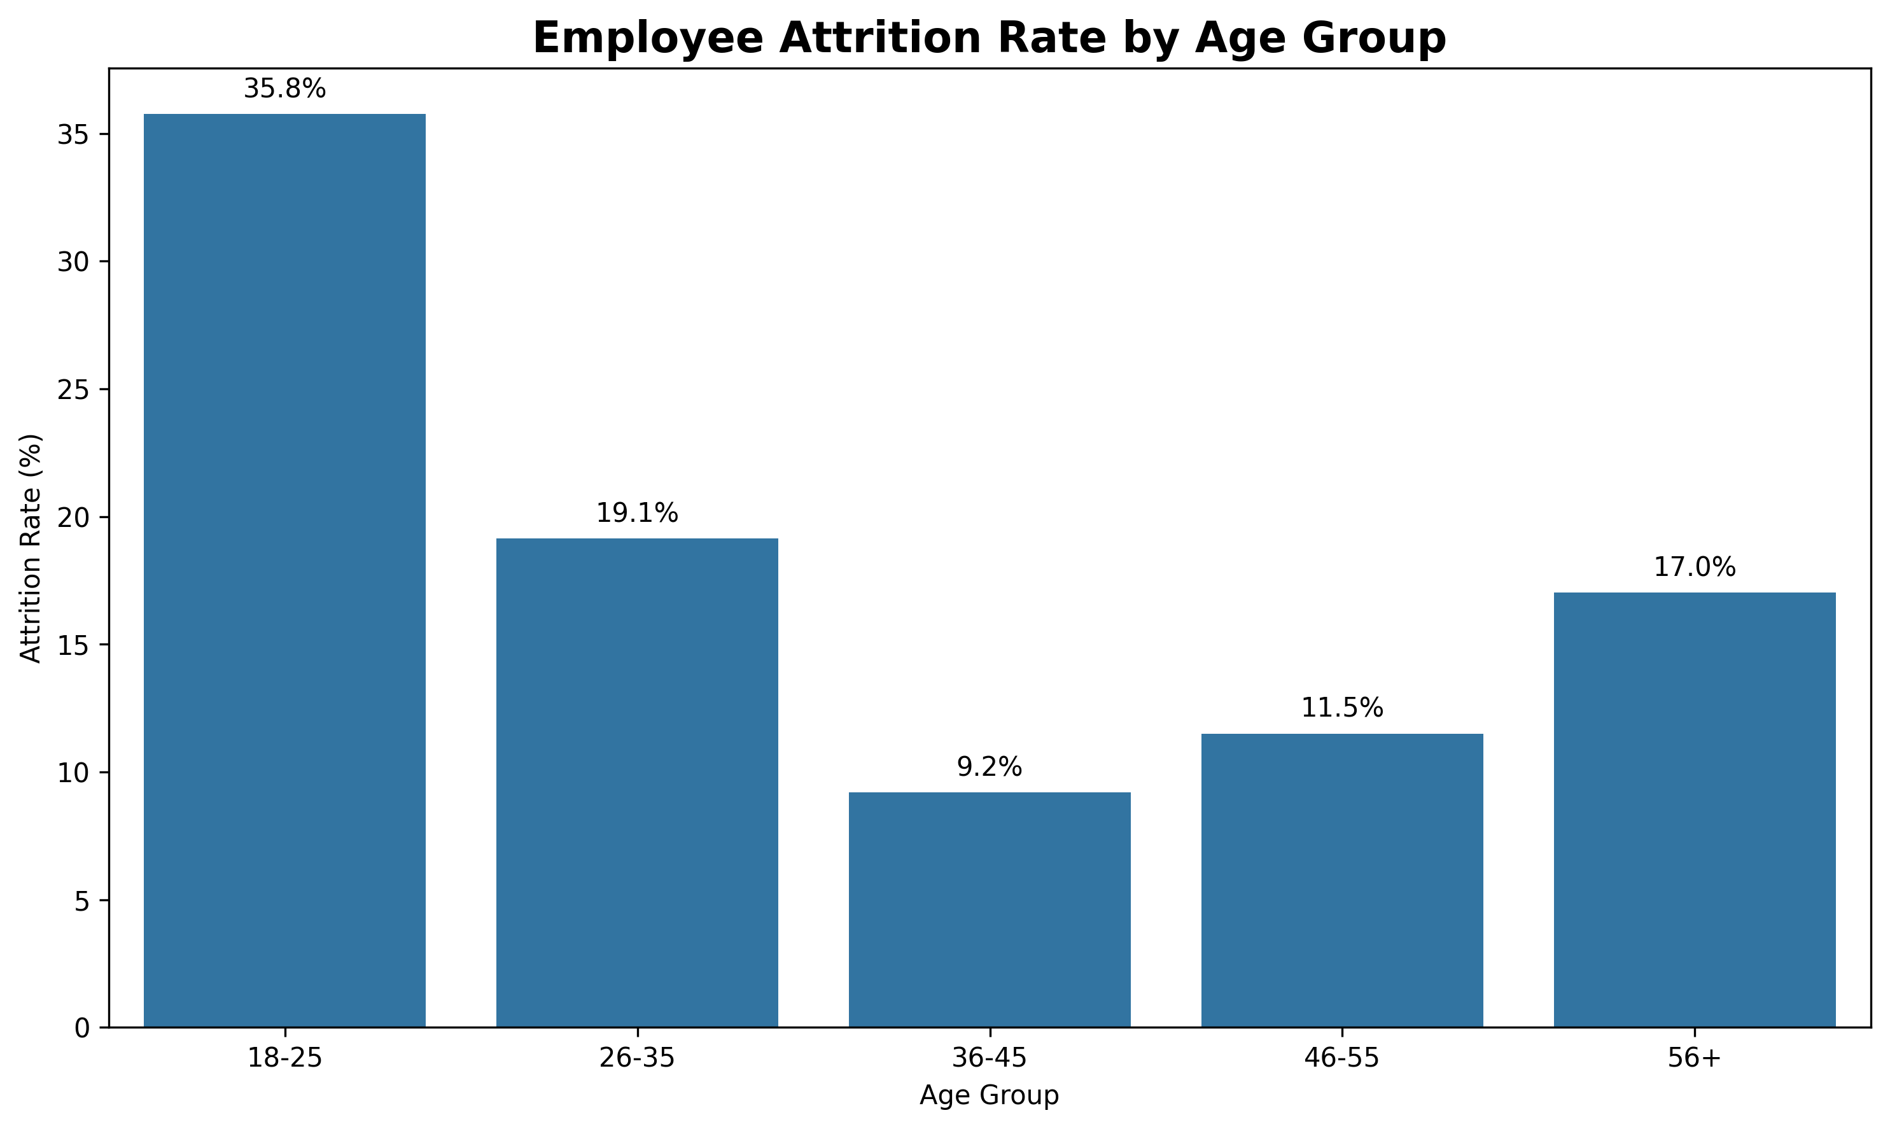
Figure 1. Employee attrition rate across different age groups.
This bar chart compares the percentage of employees who left the organization within each age group. Attrition rate is used instead of raw counts so that age groups can be compared fairly. The visualization contributes to the story by showing whether employee turnover is concentrated in particular stages of the employee life cycle.

4. Visualization 2: Attrition Rate by Job Role
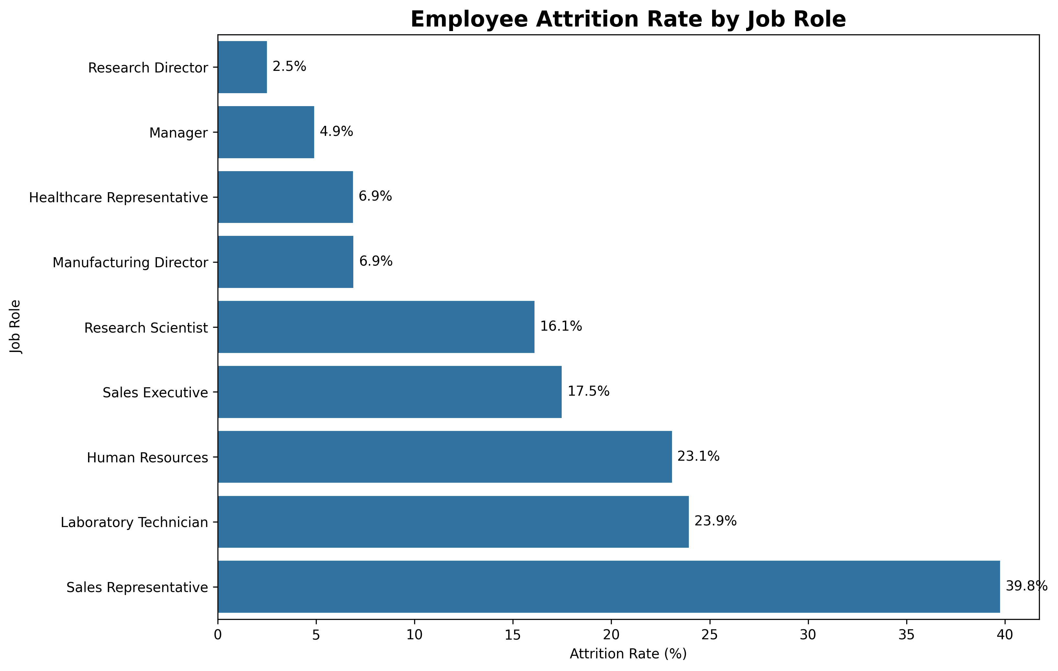
Figure 2. Employee attrition rate by job role.
The horizontal bar chart ranks job roles according to their attrition rates. This makes it easy to identify roles that experience relatively higher turnover. From a business perspective, the visualization can help HR teams prioritize specific roles for additional investigation.

5. Visualization 3: Monthly Income by Job Level and Attrition
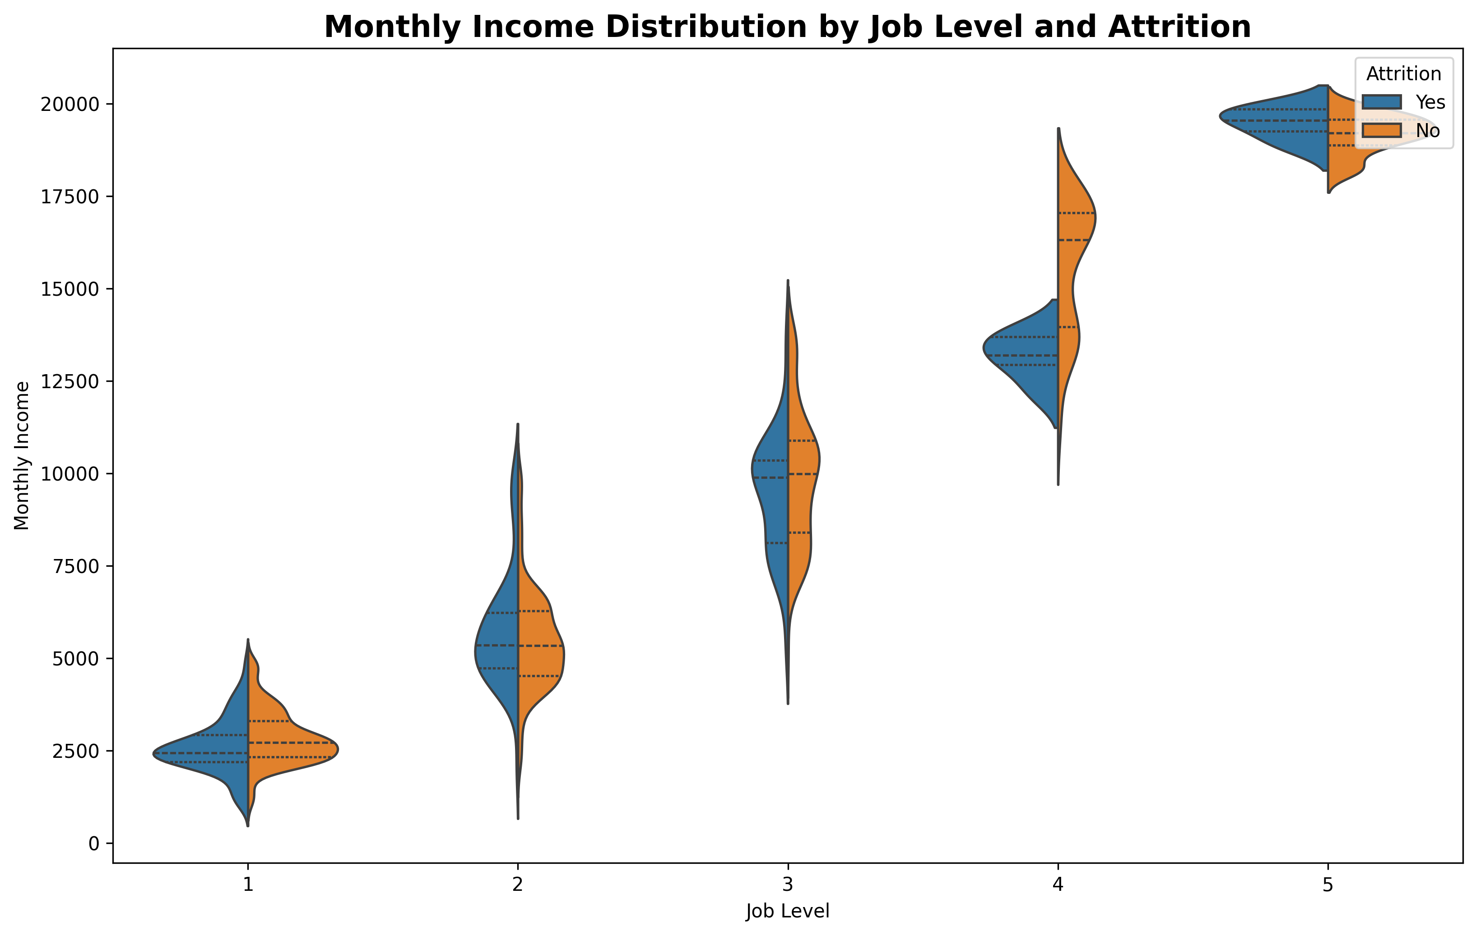
Figure 3. Monthly income distribution by job level and attrition status.
The violin plot provides a detailed view of monthly income distributions for employees who stayed and employees who left at different job levels. The chart shows central tendency, spread and distribution shape. This is more informative than using a single average salary because income variation within each job level can also be examined.

6. Visualization 4: Satisfaction Factors and Attrition
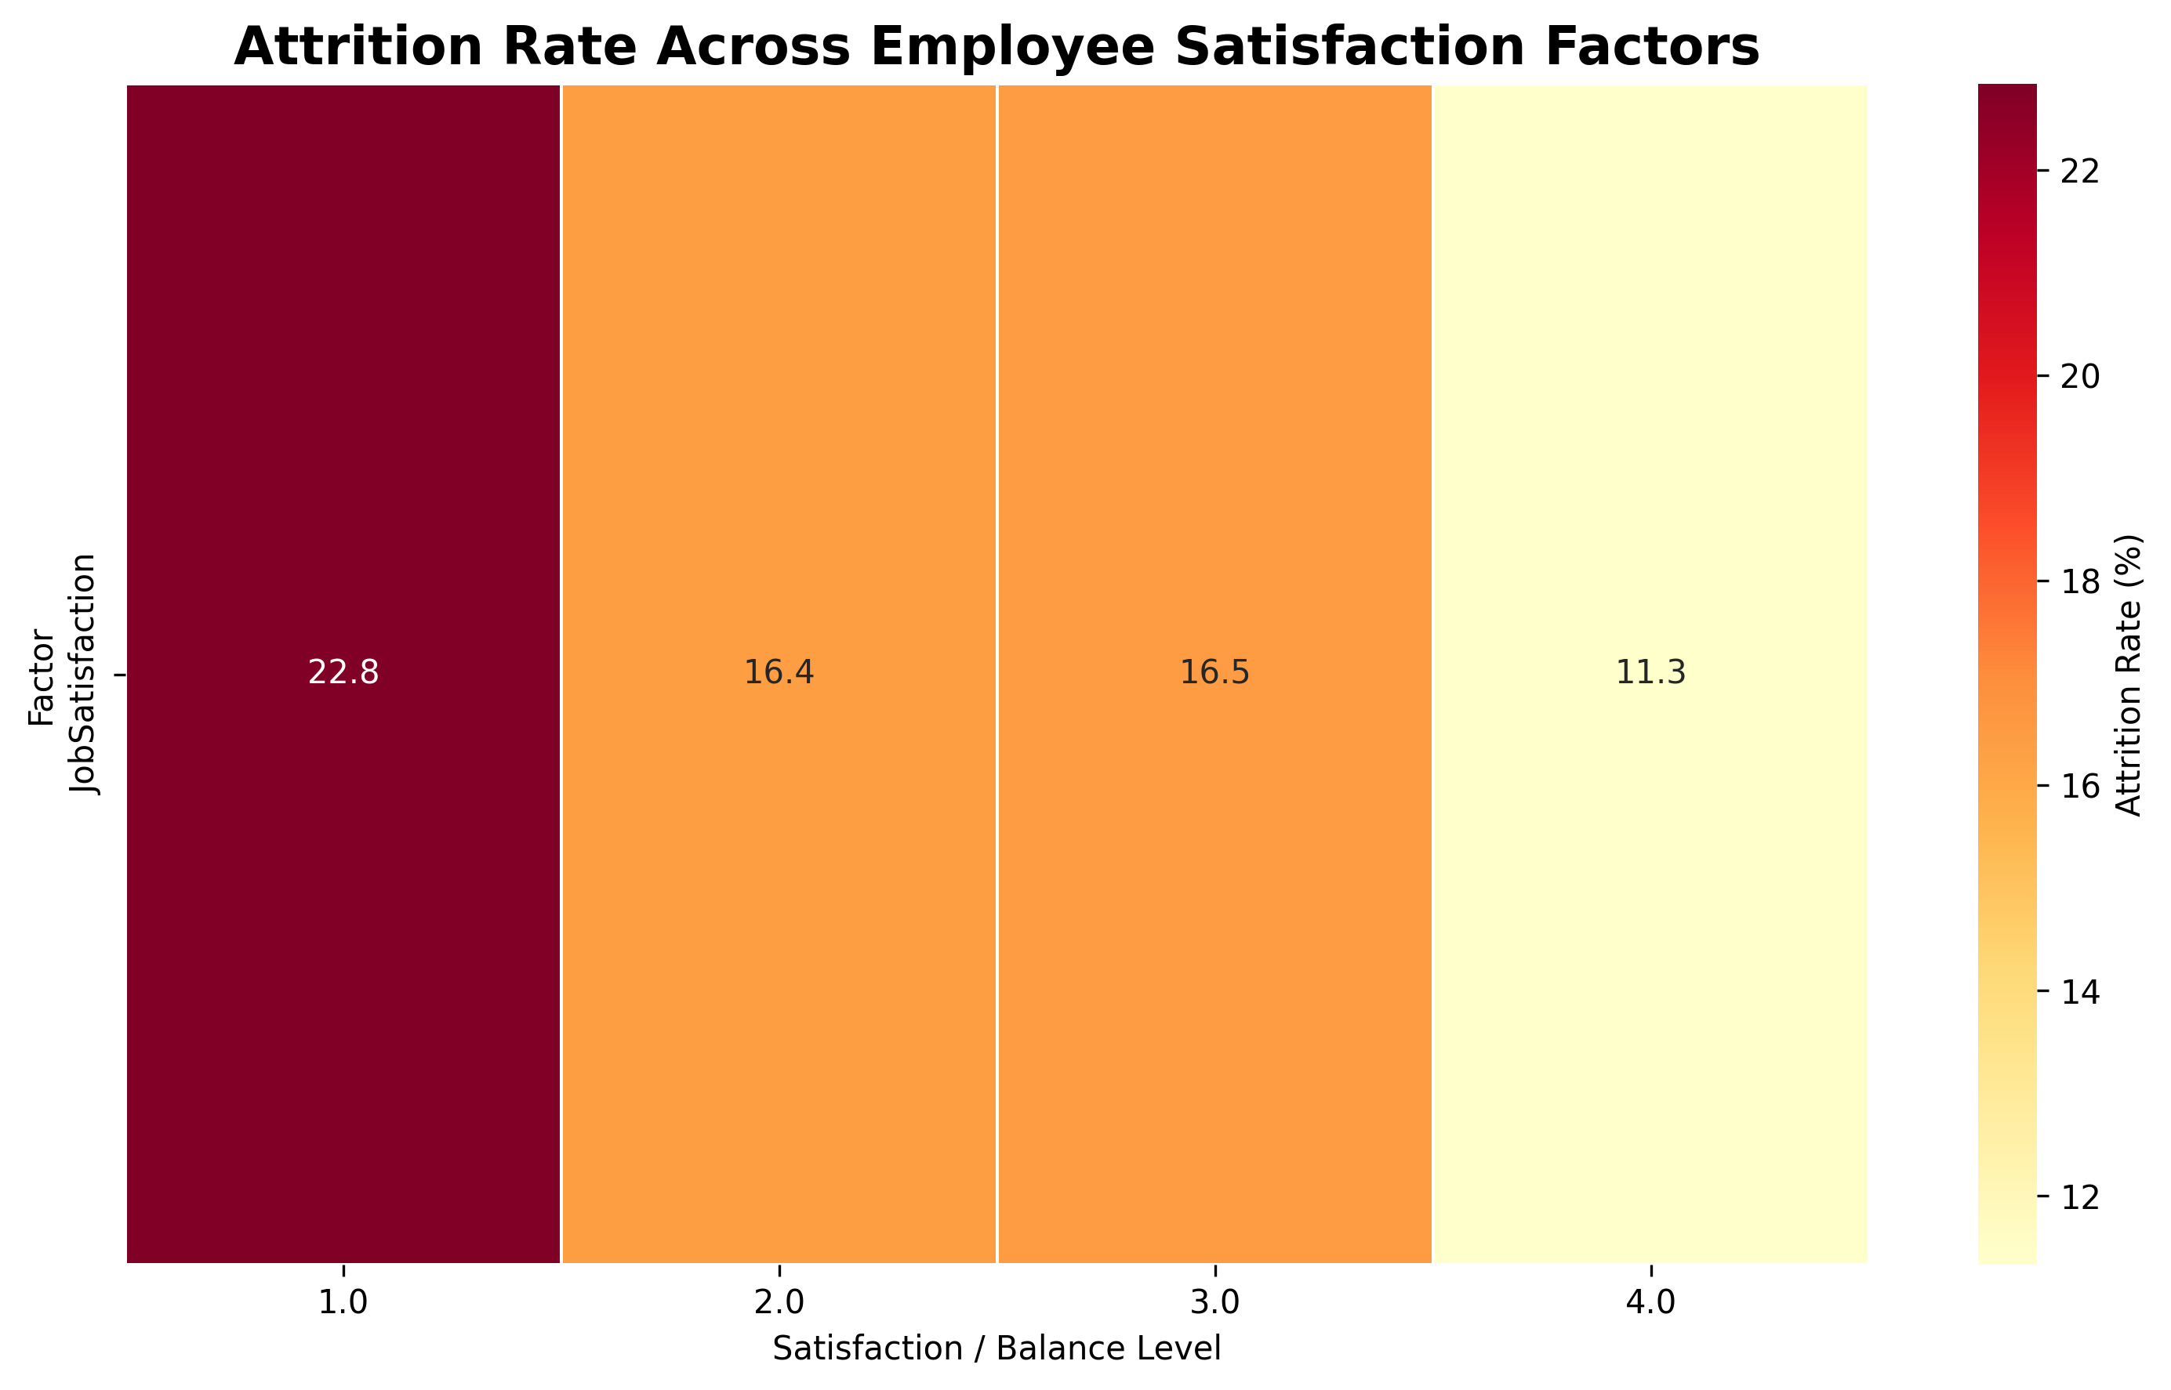
Figure 4. Attrition rate across satisfaction and work-life balance factors.
This heatmap compares attrition rates across job satisfaction, environment satisfaction, relationship satisfaction and work-life balance levels. The use of color intensity allows several employee-experience dimensions to be compared in one compact visual. It helps identify combinations of low or high satisfaction that may deserve additional analysis.

7. Visualization 5: Overtime and Job Level vs Attrition
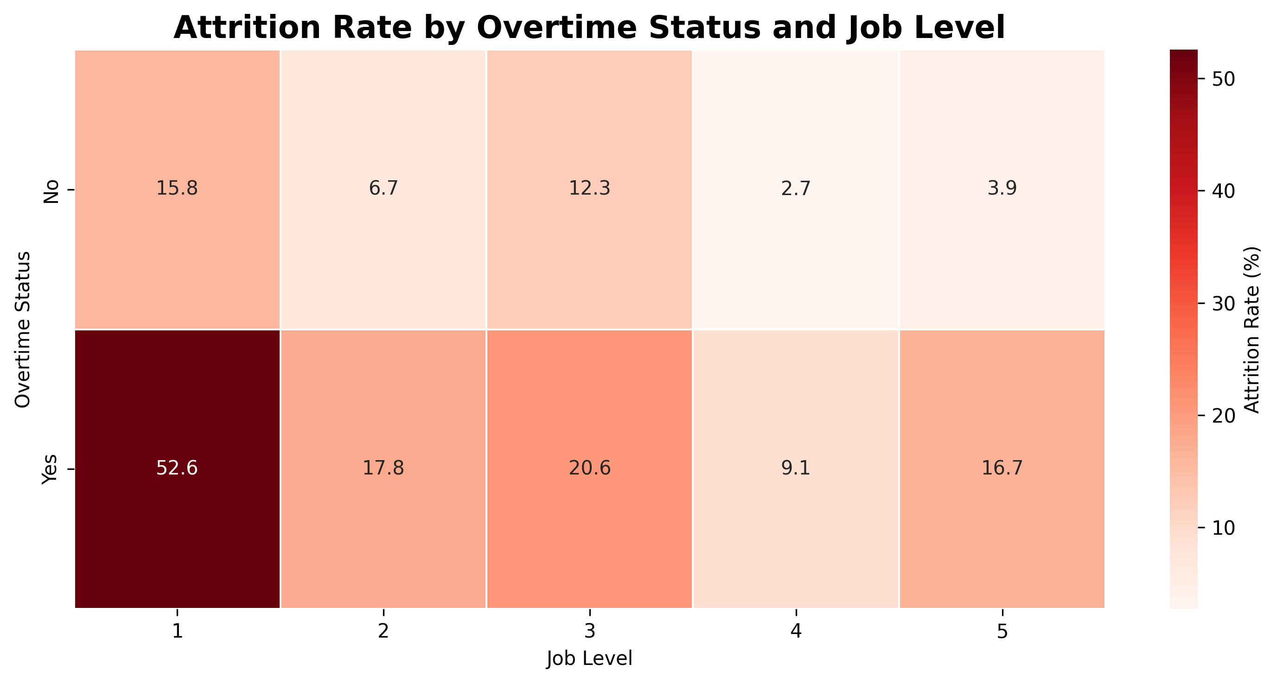
Figure 5. Attrition rate by overtime status and job level.
This heatmap combines overtime status and job level to examine whether attrition rates differ across these two dimensions. The visualization strengthens the overall story because it moves from individual factors toward the interaction of multiple employee characteristics.

8. Key Insights
- The overall employee attrition rate in the cleaned dataset is approximately 16.12%.
- The age-group analysis identifies 18-25 as the age group with the highest observed attrition rate (35.77%).
- The job-role analysis identifies Sales Representative as the job role with the highest observed attrition rate (39.76%).
- Among overtime categories, employees with 'Yes' overtime status have the higher observed attrition rate (30.53%).
- Monthly income should be interpreted together with job level because income distributions vary substantially across levels.
- Satisfaction, work-life balance and overtime provide useful employee-experience dimensions for further attrition analysis.

9. Business Implications
- HR teams can prioritize high-attrition job roles for deeper retention analysis.
- Age-group differences can help organizations design more targeted career development and retention strategies.
- Compensation distributions should be studied together with job level rather than using salary alone as an explanation for attrition.
- Overtime patterns can help HR investigate workload, employee burnout and work scheduling practices.
- Satisfaction and work-life balance measures can be used as early warning indicators for potential employee turnover.
- The findings should be treated as associations rather than proof of causation. Additional statistical testing and predictive modeling would be required before making causal claims.

10. Overall Data Story
The visualizations build a progression from broad employee characteristics toward more detailed workplace factors. The analysis first considers age and job role, then examines compensation, satisfaction and overtime. This sequence helps move from the question of where attrition is concentrated to the question of which employee and workplace characteristics may be associated with that attrition.

11. Conclusion
Week 2 successfully extended the Week 1 exploratory analysis through advanced visualization and storytelling. Five new visualizations were created to communicate different aspects of employee attrition. The analysis shows that turnover should not be interpreted through a single variable. Age group, job role, income, job level, satisfaction, work-life balance and overtime all provide different perspectives.
The findings can guide future analysis such as statistical hypothesis testing, feature importance analysis and employee attrition prediction. However, the relationships shown in the visualizations should not be interpreted as proof of causation. Further statistical and machine learning methods would be required before making causal or predictive claims.

